SEARCH ARTICLES

Success with Air Plants
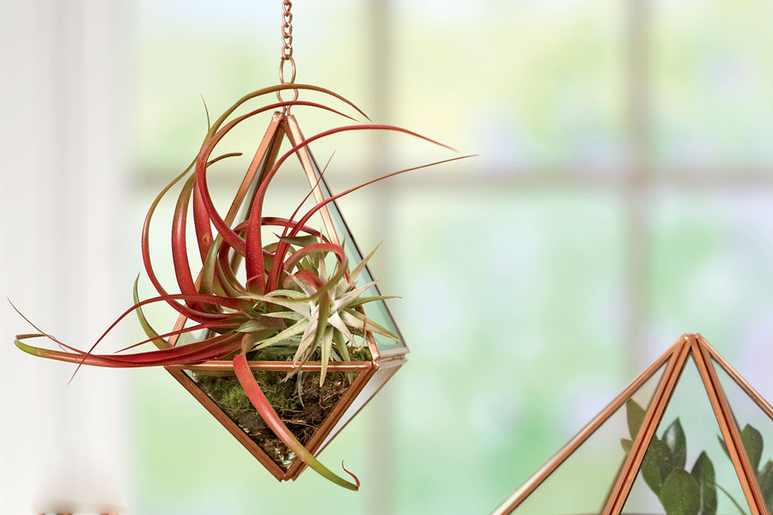
An air plant is especially easy to care for. Photo: Hanging Prism Terrarium
By Ann Whitman
NO luck with houseplants or just want something new? Try an air plant! These tropical plants are epiphytes, which means they don't need potting soil and require only minimal care. Tiny scales on their leaves, called trichomes, absorb water and nutrients directly from the air, and even help shade the plant from scorching sun. The plants' "roots" are used only for clinging and do not absorb water and nutrients like earthbound plants.
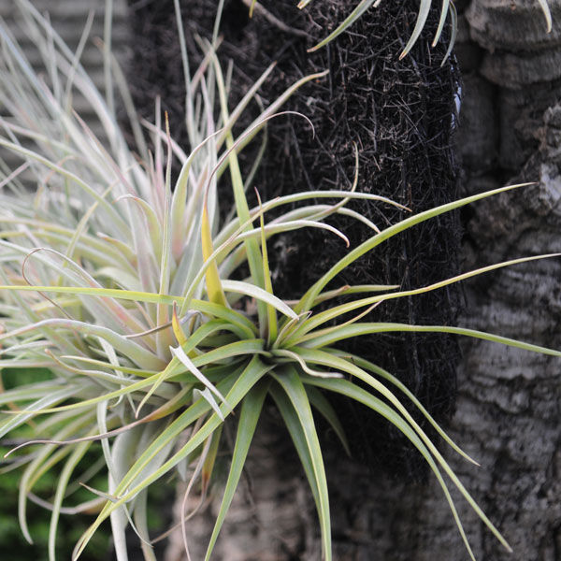
Air plants attached to a piece of bark. Wire holds the plants in place.

Decorating with air plants
Air plants, aka tillandsias, are perfect for craft projects, small-space living, and finally giving brown-thumb gardeners some bragging rights. Tuck them into shells and driftwood crevices, glass baubles and wire baskets, or superglue their roots to stones or wood. Place them amongst your larger houseplants, between the leaves or around the base. They make ideal companions for orchids, cactus and bromeliads. Or, just set them unadorned on a windowsill or sunny shelf.
SHOP FOR TERRARIUMS

Light and temperature
All air plants come from tropical climates where cold and freezing never occur. It's important to keep them at temperatures you find comfortable without a sweater—generally from the 60s and warmer. Avoid placing them close to air conditioner vents and cold winter windows.
Air plants do best with at least a few hours of bright, indirect sun daily. Placement within 1 to 3 feet of an east- or west-facing window, or within a foot or two of an artificial light source is ideal. If you keep them well watered, they can have hotter, more direct sun and longer exposure. Avoid dimly lit locations.

Watering and fertilizing
The appearance of your air plant's leaves can give you clues about how to care for it.
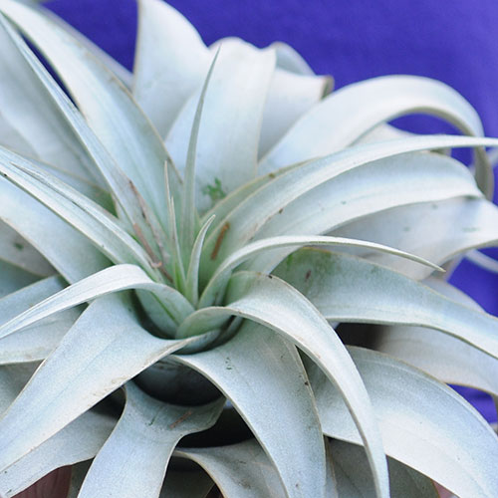
Xeric air plant
Fuzzy leaves with feathery, white, silvery, and dusty coatings indicate xeric types that come from sunny, dry climates, where rainfall is less frequent. Their pronounced trichomes collect maximum water when it falls and hold it for use during dry periods. They need watering only once or twice a week and can tolerate more sun.

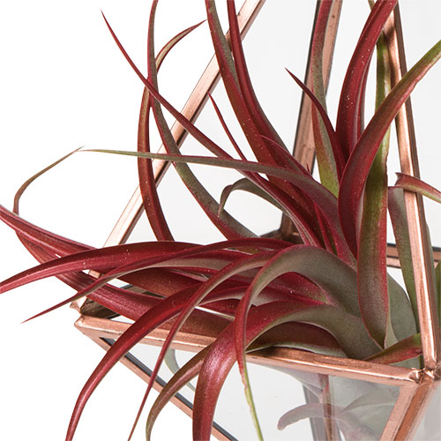
Mesic air plant
Smooth, glossy leaves are most common on mesic types that come from shaded, moist rain and cloud forests, where water is plentiful. They have less pronounced trichomes and less protection from drying out and hot sun. They need more frequent watering.

The best way to water your air plant depends on the plant, its location and your own preferences. Use room temperature tap or rainwater, but never softened water because the salt in it can damage your plants. Choose the most convenient method for you and your plants:
- Misting is perfect for plants inside globes or displays, and for people who like daily interaction with their plants. Mist three to seven times a week, depending on the type of plant, and try to wet all surfaces.
- Dunking is good for plants that are attached to wood or freestanding, as well as those with dense or very curly leaves that are hard to mist thoroughly. Dip the whole plant briefly into a pan of water or a freshwater fish tank, or put under a running faucet. Use this method two to four times per week for mesic types and once a week for xeric types.
- Soaking helps revive dry plants. Submerge the whole plant for 1 to 3 hours. Use this method once a week or after a period of neglect.
After watering, shake out the excess so that no standing water remains in the center. Let plants dry in a well-ventilated place so they don't remain wet. Water more frequently in air conditioning, hot weather and desert climates, and less frequently in cool, cloudy weather. Tip: When "planting" avoid tucking them into moss that stays damp, which may cause air plants to rot.
Fertilize air plants once or twice a month with a water-soluble orchid or tillandsia fertilizer, following package instructions for dilution. Use the misting or dunking method. These special fertilizers do not contain urea nitrogen, which air plants cannot use. Tip: If your plant is very dry, soak it first, then fertilize it the next day.

